GARDEN GLORY PROJECT QUESTIONS

- Write CREATE TABLE statements for each of these tables.

- Write foreign key constraints for the relationships in each of these tables. Make your own assumptions regarding cascading updates and deletions, and justify those assumptions. (Hint: You can combine the SQL for your answers to Questions A and B.)

- Write SQL statements to insert the data into each of these tables. Assume that any surrogate key value will be supplied by the DBMS. Use the data in Figures 3-30, 3-31, 3-32, 3-33, and 3-34.
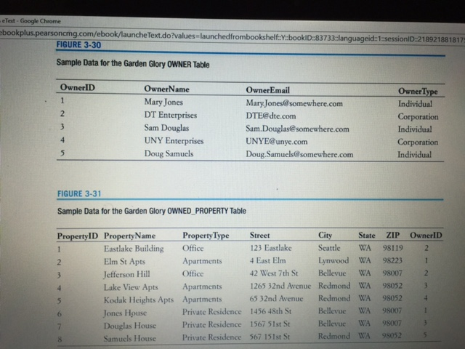
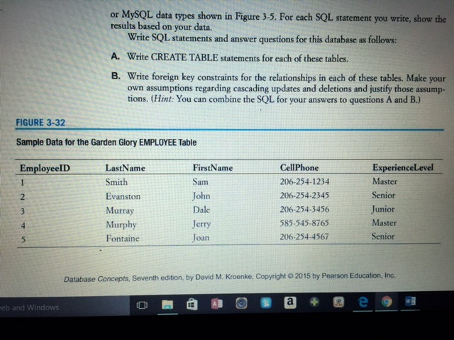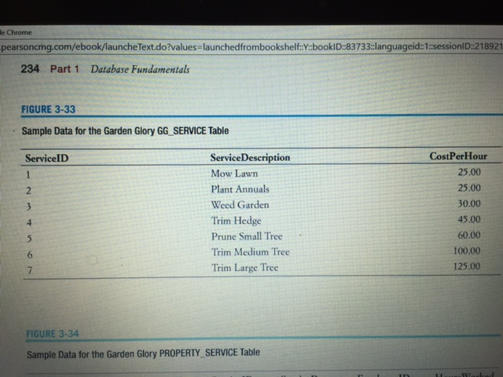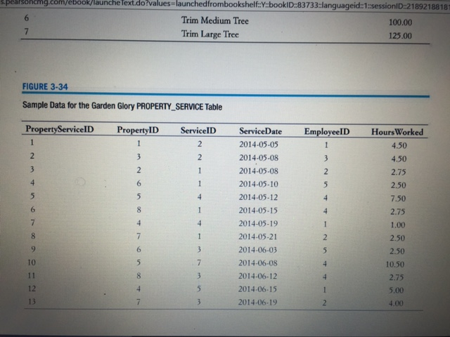
- Write SQL statements to list all columns for all tables.

Garden Glory Project Questions
If you have not already implemented the Garden Glory database shown in Chapter 3 in a DBMS product, create and populate the GG database now in the DBMS of your choice (or as assigned by your instructor). (See Below)
- Create a user named GG-User with the password GG-User+password. Assign this user to database roles so that the user can read, insert, delete, and modify data.

- If you haven’t completed Exercise 7.50, do it now.

- Add a new folder to the DBC website named GG. Create a web page for Garden Glory in this folder—using the file name index.html. Link this page to the DBC web page.

- Create an appropriate ODBC data source for your database.

